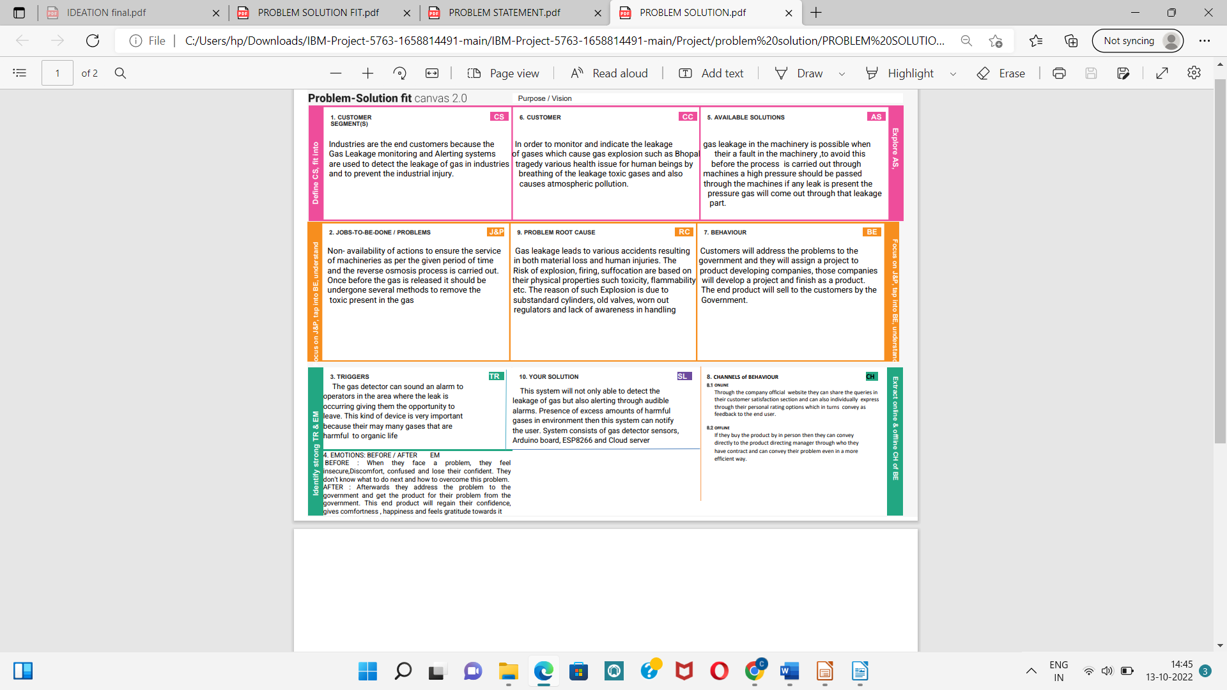
Project Design Phase-I
Problem Solution Fit

Date | 09/21/22
Team ID | PNT2022TMID15909
Project Name | Gas leakage monitoring and alerting system for industries
Mark | 4 mark

